A Report on
Project Fair
“AAVISHKAR-2022” organized by SSIP cell, Government Polytechnic, Godhra
On
18th April, 2022.

Project fair “AAVISHKAR-2022” has been organized by SSIP cell, Government Polytechnic, Godhra, for the final year students of Civil, Mechanical & Electrical engineering department on 18th April, 2022. The purpose of the event is to facilitate the projects of final year students. Also to encourage development of Innovative skills among students.
The event was being inaugurated by Principal, Heads and Experts at 11.00 am in the auditorium hall. Key note lecture was delivered by The Principal and all HODs and invited experts.
Models, Charts and Presentation prepared by participants were being exhibited.

Number of groups participated:
SR NO | DEPARMENT | TOTAL NO OF GROUPS
1 | MECHANICAL | 20
2 | ELECTRICAL | 22
3 | CIVIL | 18

Experts from different fields were being invited for the evaluation and ranking of student’s projects. Details of experts is as follows:

SR NO | DEPARMENT | NAME OF EXPERT | DESIGNATION
1 | CIVIL | Prof. K P SHAH | Assistant Professor, Civil Engineering department,  GEC Godhra.
2 | MECHANICAL | Prof.Dr. A V mehta | Assistant Professor, Mechanical Engineering department,  GEC Godhra.
3 | MECHANICAL | Prof.Dr. Amit Patel | Assistant Professor, Mechanical Engineering department,  GEC Godhra.
4 | ELECTRICAL | Prof. Niti Desai | Assistant Professor,  I/C Head,Electrical Engineering department,  GEC Godhra.

The winners of the event is as follows:

SR NO | DEPARTMENT | PROJECT NAME | RANK
1 | CIVIL | Advanced Drip Irrigation system | 1st
2 | CIVIL | Computer aided reinforced concrete structures design | 2nd
3 | CIVIL | Assessment of Govt.Polytechnic Godhra, existing campus as per IGBC | 3rd
4 | MECHANICAL | Investigations on low cost desalinator | 1st
5 | MECHANICAL | Design and development of eco-friendly solar cooker using parabolic dish as a solar collector | 2nd
6 | MECHANICAL | Design and development of combined parabolic collector for cooking application | 3rd
7 | ELECTRICAL | Solar tracking system | 1st
8 | ELECTRICAL | Solar operated accident avoiding ir car | 2nd
9 | ELECTRICAL | Bi-direction speed control of d.c.motor | 3rd

GLIMPSE OF THE EVENT “AAVISHKAR-2022”

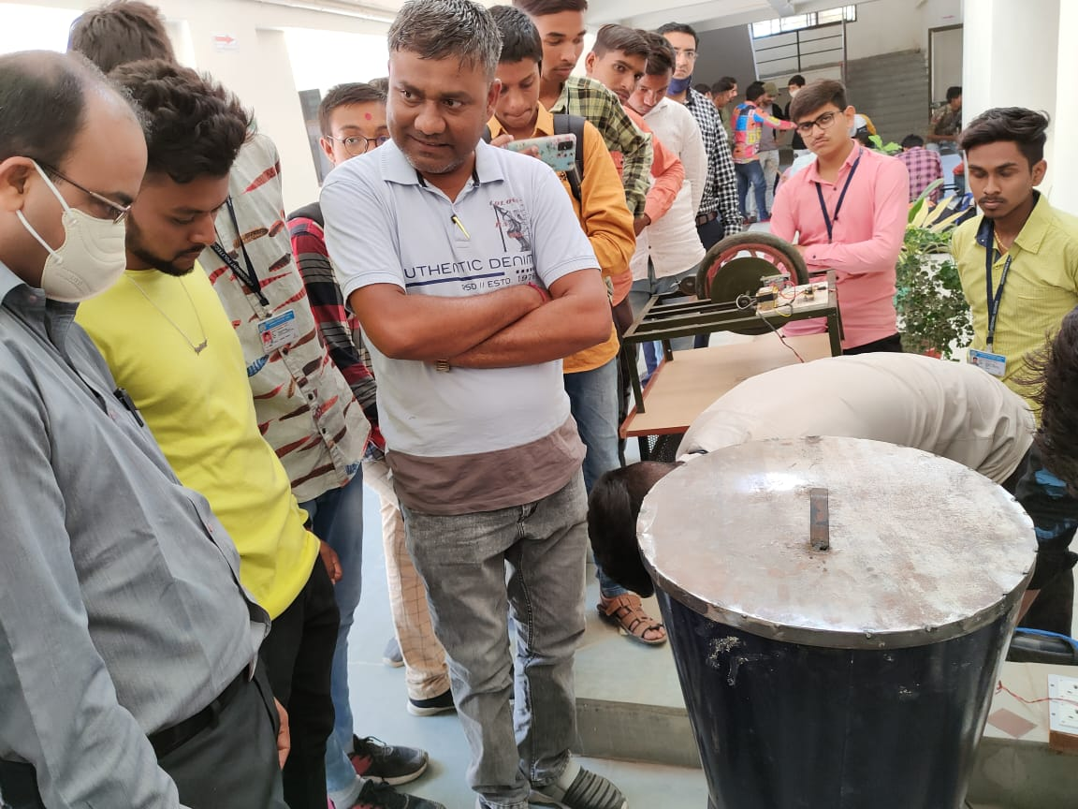 | 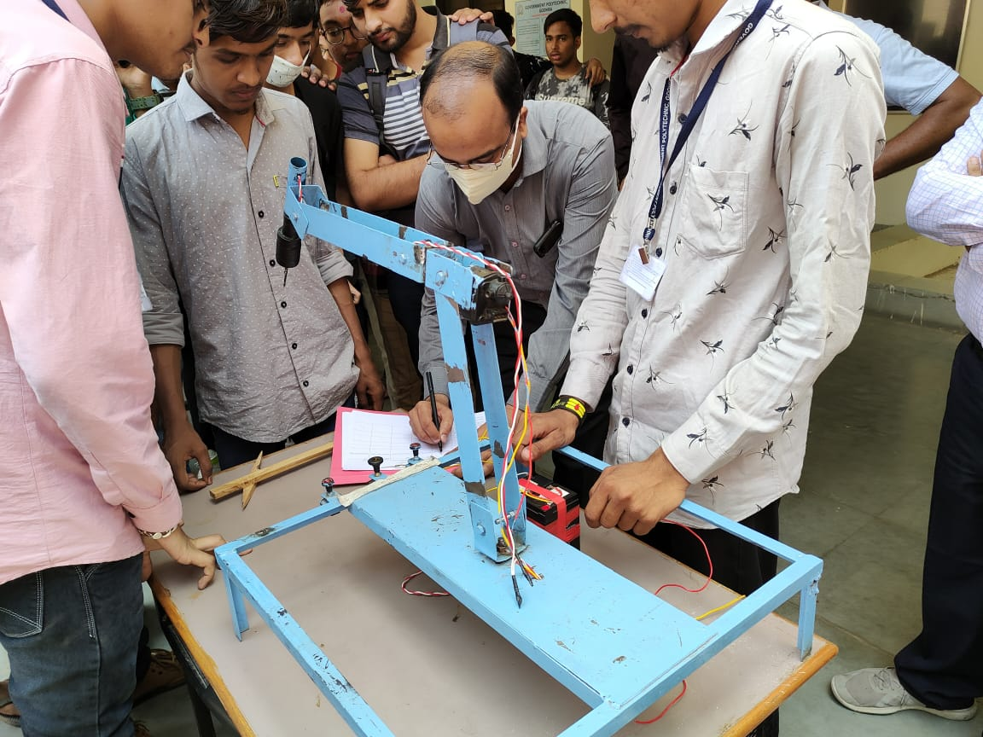
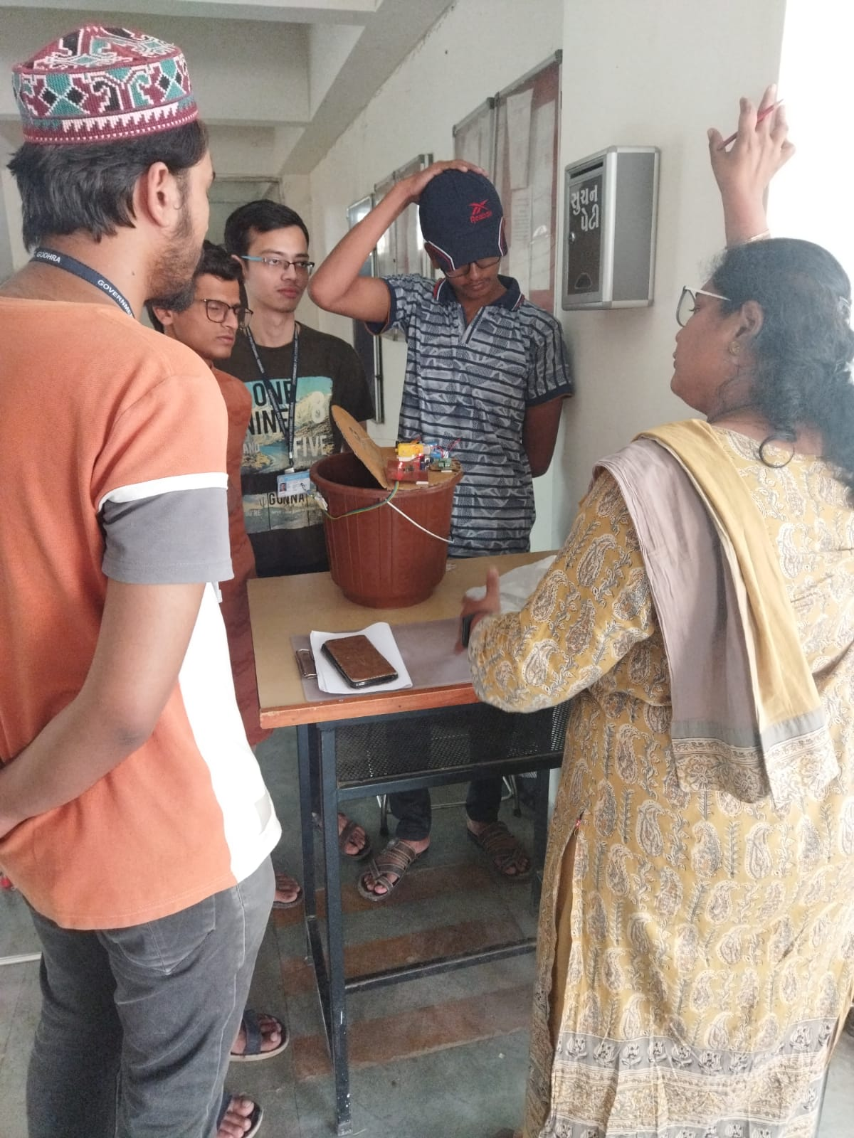 | 